[Thực hành] Sử dụng Bootstrap xây dựng form login

Mục tiêu
Sử dụng được bootstrap

Mô tả
Xây dựng form login đăng nhập tài khoản bằng bootstrap như sau:
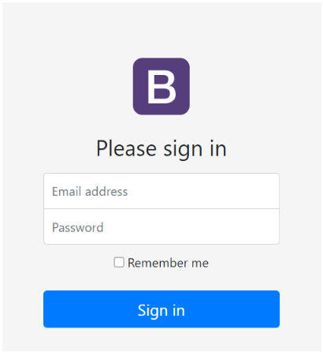

Hướng dẫn
Bước 1: Tạo một dự án mới bằng Webstorm và tạo một file index.html
Bước 2: Truy cập trang web https://getbootstrap.com/docs/5.0/getting-started/introduction/ để cài boostrap vào trong file HTML
<!doctype html>
<html lang="en">
<head>
<!-- Required meta tags -->
<meta charset="utf-8">
<meta name="viewport" content="width=device-width, initial-scale=1">
<!-- Bootstrap CSS -->
<link href="https://cdn.jsdelivr.net/npm/bootstrap@5.0.0-beta2/dist/css/bootstrap.min.css" rel="stylesheet"
integrity="sha384-BmbxuPwQa2lc/FVzBcNJ7UAyJxM6wuqIj61tLrc4wSX0szH/Ev+nYRRuWlolflfl" crossorigin="anonymous">
<title>Hello, world!</title>
</head>
<body>
<h1>Hello, world!</h1>
<script src="https://cdn.jsdelivr.net/npm/bootstrap@5.0.0-beta2/dist/js/bootstrap.bundle.min.js"
integrity="sha384-b5kHyXgcpbZJO/tY9Ul7kGkf1S0CWuKcCD38l8YkeH8z8QjE0GmW1gYU5S9FOnJ0"
crossorigin="anonymous"></script>
</body>
</html>
Chạy thử chương trình xem đã thêm được thư viện bootstrap chưa

Bước 3: Tải 1 ảnh icon bootstrap và lưu vào trong thư mục
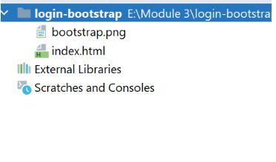
Bước 4: Thêm đoạn HTML sau để hiển thị form đăng nhập
<!doctype html>
<html lang="en">
<head>
<!-- Required meta tags -->
<meta charset="utf-8">
<meta name="viewport" content="width=device-width, initial-scale=1">
<!-- Bootstrap CSS -->
<link href="https://cdn.jsdelivr.net/npm/bootstrap@5.0.0-beta2/dist/css/bootstrap.min.css" rel="stylesheet"
integrity="sha384-BmbxuPwQa2lc/FVzBcNJ7UAyJxM6wuqIj61tLrc4wSX0szH/Ev+nYRRuWlolflfl" crossorigin="anonymous">
<title>Login</title>
</head>
<body class="text-center">
<form class="form-signin">
<img class="mb-4" src="bootstrap.png" alt="" width="72"
height="72">
<h1 class="h3 mb-3 font-weight-normal">Please sign in</h1>
<input type="email" id="inputEmail" class="form-control" placeholder="Email address" required autofocus>
<input type="password" id="inputPassword" class="form-control" placeholder="Password" required>
<div class="checkbox mb-3">
<label>
<input type="checkbox" value="remember-me"> Remember me
</label>
</div>
<button class="btn btn-lg btn-primary btn-block" type="submit">Sign in</button>
<p class="mt-5 mb-3 text-muted">&copy; 2017-2018</p>
</form>
<script src="https://cdn.jsdelivr.net/npm/bootstrap@5.0.0-beta2/dist/js/bootstrap.bundle.min.js"
integrity="sha384-b5kHyXgcpbZJO/tY9Ul7kGkf1S0CWuKcCD38l8YkeH8z8QjE0GmW1gYU5S9FOnJ0"
crossorigin="anonymous"></script>
</body>
</html>
Bước 5: Tạo file styles.css như sau:
html,
body {
height: 100%;
}
body {
display: -ms-flexbox;
display: -webkit-box;
display: flex;
-ms-flex-align: center;
-ms-flex-pack: center;
-webkit-box-align: center;
align-items: center;
-webkit-box-pack: center;
justify-content: center;
padding-top: 40px;
padding-bottom: 40px;
background-color: #f5f5f5;
}
.form-signin {
width: 100%;
max-width: 330px;
padding: 15px;
margin: 0 auto;
}
.form-signin .checkbox {
font-weight: 400;
}
.form-signin .form-control {
position: relative;
box-sizing: border-box;
height: auto;
padding: 10px;
font-size: 16px;
}
.form-signin .form-control:focus {
z-index: 2;
}
.form-signin input[type="email"] {
margin-bottom: -1px;
border-bottom-right-radius: 0;
border-bottom-left-radius: 0;
}
.form-signin input[type="password"] {
margin-bottom: 10px;
border-top-left-radius: 0;
border-top-right-radius: 0;
}
Cập nhật lại file index.html
<!doctype html>
<html lang="en">
<head>
<!-- Required meta tags -->
<meta charset="utf-8">
<meta name="viewport" content="width=device-width, initial-scale=1">
<!-- Bootstrap CSS -->
<link href="https://cdn.jsdelivr.net/npm/bootstrap@5.0.0-beta2/dist/css/bootstrap.min.css" rel="stylesheet"
integrity="sha384-BmbxuPwQa2lc/FVzBcNJ7UAyJxM6wuqIj61tLrc4wSX0szH/Ev+nYRRuWlolflfl" crossorigin="anonymous">
<title>Login</title>
<link rel="stylesheet" href="styles.css">
</head>
<body class="text-center">
<form class="form-signin">
<img class="mb-4" src="bootstrap.png" alt="" width="72"
height="72">
<h1 class="h3 mb-3 font-weight-normal">Please sign in</h1>
<input type="email" id="inputEmail" class="form-control" placeholder="Email address" required autofocus>
<input type="password" id="inputPassword" class="form-control" placeholder="Password" required>
<div class="checkbox mb-3">
<label>
<input type="checkbox" value="remember-me"> Remember me
</label>
</div>
<button class="btn btn-lg btn-primary btn-block" type="submit">Sign in</button>
<p class="mt-5 mb-3 text-muted">&copy; 2017-2018</p>
</form>
<script src="https://cdn.jsdelivr.net/npm/bootstrap@5.0.0-beta2/dist/js/bootstrap.bundle.min.js"
integrity="sha384-b5kHyXgcpbZJO/tY9Ul7kGkf1S0CWuKcCD38l8YkeH8z8QjE0GmW1gYU5S9FOnJ0"
crossorigin="anonymous"></script>
</body>
</html>
Chạy lại file index.html và quan sát kết quả
Checkout sang nhánh develop để xem mã nguồn tham khảo: https://github.com/codegym-vn/jwbd-login-bootstrap

